ART HISTORICAL METHODOLOGIES 2018-19
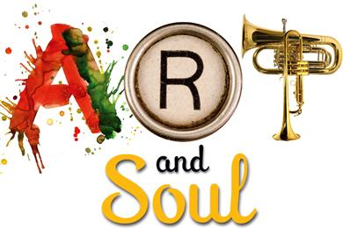
Ms. Melinda Darrow Ms. Moira Longino
Room 283 Ext. 33304 Room 354 Ext. 33326

Purpose of Course

This course is an introduction to the major methodologies that have been used and are used by art historians. It is organized in a roughly chronological order that traces major methodological developments within the discipline. By focusing on several outstanding historical and critical readings, as well as secondary discussions of different types of art historical analysis, the student will be introduced to the major methodologies that have shaped the field.

Upon successful completion of this course, the student will be able to:
- Explain what art historians study and what kinds of questions they ask about works of art.
- Identify major art historical methodologies and their associated theories and theorists.
- Write a critical summary of a piece of art historical scholarship.
- Explain the major aspects of the methodological approaches outlined in this course and how they relate to the philosophical, historical, and social context in which they first appeared.
- Explain how different methodologies can be used to analyze works of art.
- Compare and contrast the major art historical methodologies.
- Use different art historical approaches to interpret, analyze, and write about works of art.

Grading

As this is an advanced level college course, our goal is to have fewer but more meaningful grades. Here are some guiding philosophical thoughts about grading in this class:
- The ultimate passing grade is the development of the student's neurobiological systems, not an arbitrary test.
- It allows students to pursue the arts for the sheer joy of it.
- It gives students more responsibility for their own progress.
- Students become more interested in mastery than in trying to earn a grade.
- Teachers and students can work collaboratively to reach a common goal.
- Students can explore their own creative interests without trying to please a teacher or narrowing their focus to grade-related outcomes.

What comprises the report card grade for each nine weeks includes:

Major (70%):
1. Processfolio (ongoing) that includes artifacts, journals, work samples, learning logs, interviews, peer feedback, recordings, art videos, learning profile, matching work with agreed-on activity checklists, gallery walks, questionnaires, peer observations, feedback by adults outside of class, video observations, student-teacher conferences
2. An essay, presentation, creation, or other evidence of understanding and applying the learning theories each nine weeks

Daily (30%):
Attendance, participation, effort, discussion, collaboration, communication, daily journals.
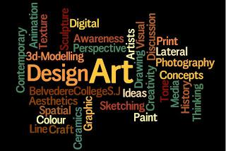
Methods Syllabus

FALL
1. Integrated Arts: Brain and Design
2. Ancients Theory
3. Medieval Theory
4. The Academy
5. Renaissance Theory
6. 17th Century Theory
7. Winckelmann and Emergence of Modernism
8. Curation Show

SPRING
9. Color Theory
10. Connoirsseurship
11. Zeitgeist and Clement Greenberg
12. Sociological Perspective
13. Gender Theory
14. Psychoanalytical Theory
15. Postcolonial Theory
16. Museum Studies and Preservation
17. Lacan and the Gaze
18. Applied Art History: Art Direction

Materials:

You may use traditional and/or electronic materials according to your preference and learning style. Journal submissions will be through Google Classroom or, if you prefer, in a composition notebook. You will have a classroom folder in which to store materials and to receive project feedback forms.

